**PRACTICAL: 5**

**IMPLEMENT ESXI SERVER**

**Deploying a VM Running ESXi on VMware Workstation**

**Steps:**

1.Open VMware Workstation – And select Create a New Virtual Machine

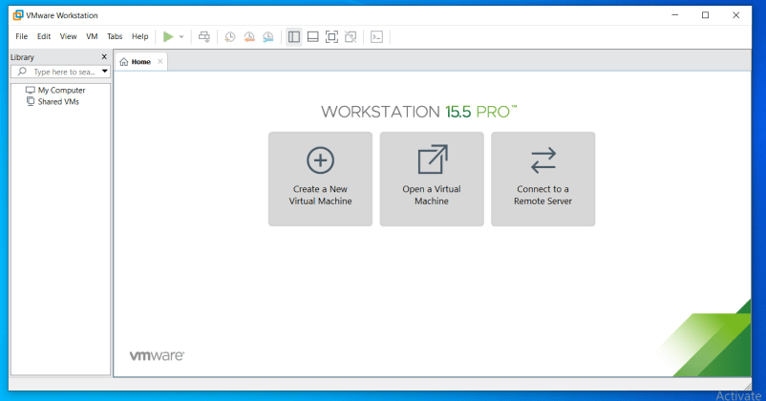

2.Select Typical and click Next

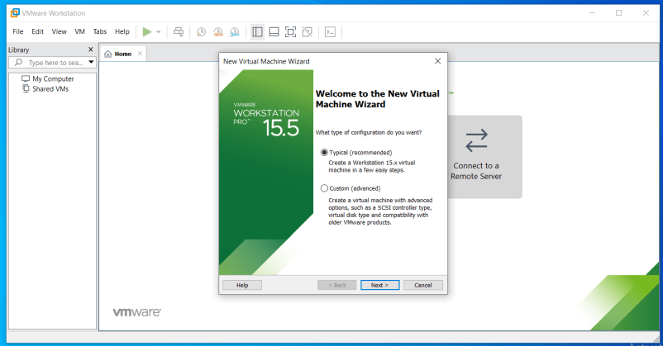

3. Select Installer disc_image file(ISO). Click Browse -ESXi-5.x-Custom.iso Iso File and click on next

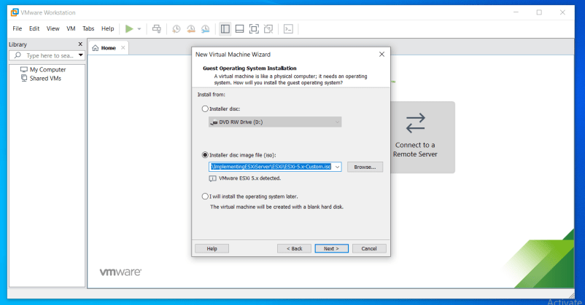

4. Change maximum disk size to 60 GB and check –Store virtual disk as single file

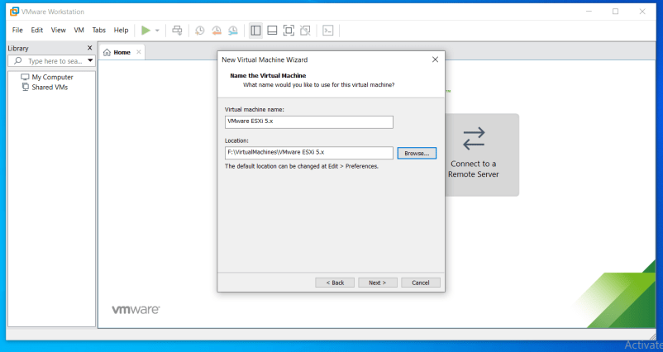

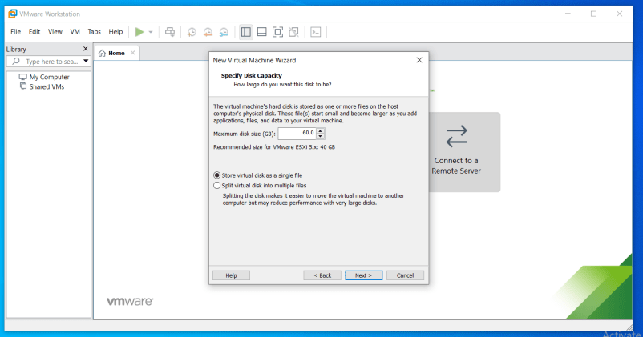

Click on Customize Hardware option

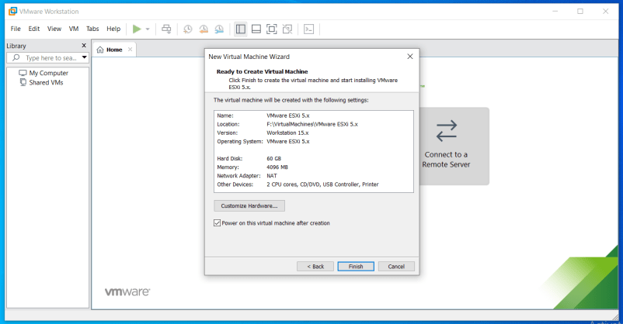

Change – Memory for this virtual machine to 4 GB and Click on Close. Click on Processor and select virtualize Intel VT

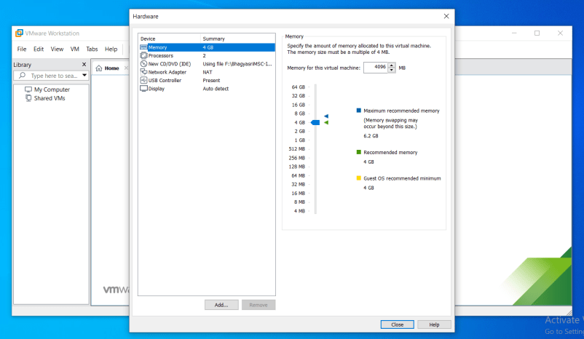

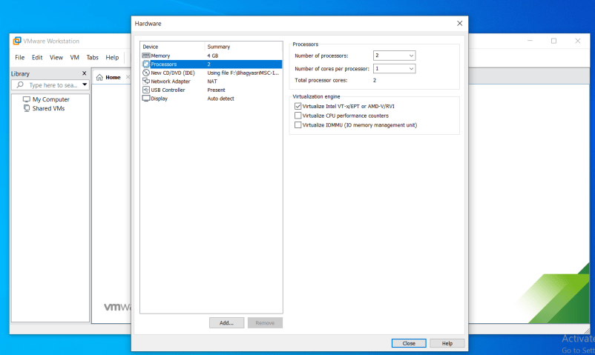

5.Click on finish button on “Ready to Create Virtual machine” window

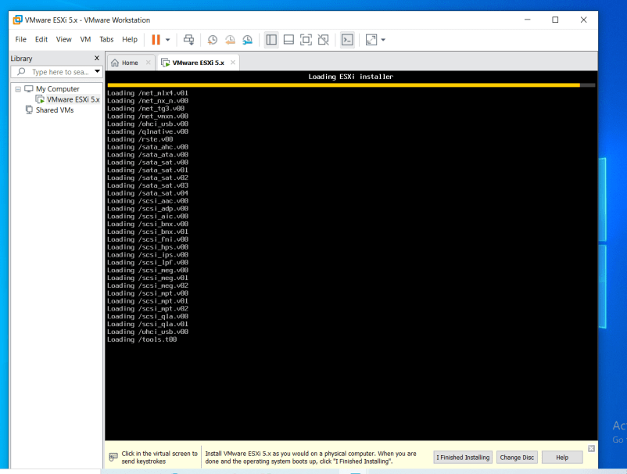

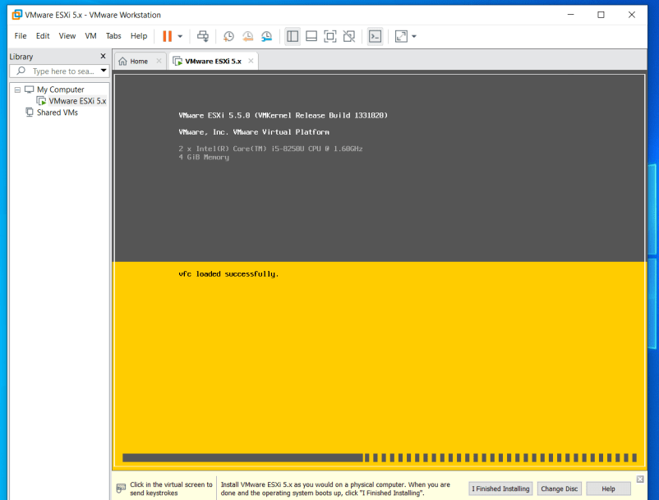

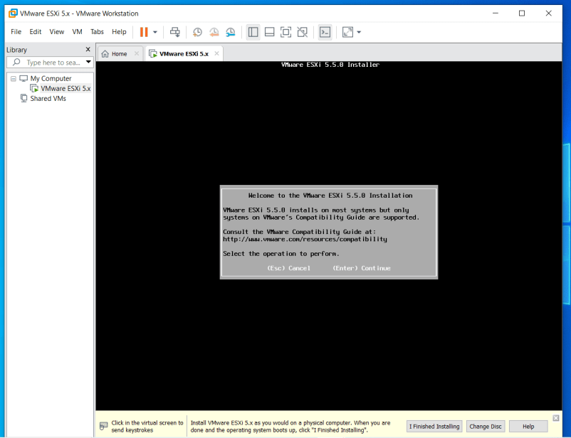

Press “Enter”

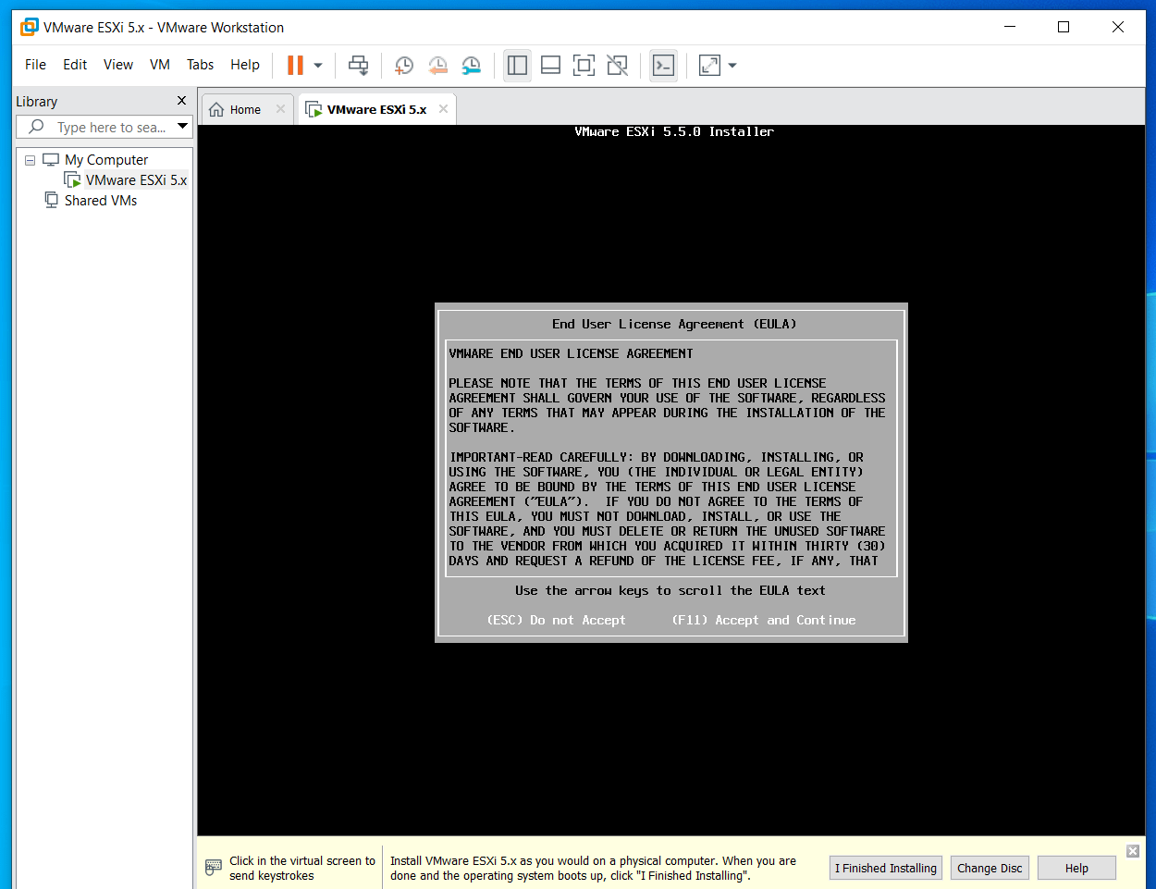

Press F11(Accept and Continue)

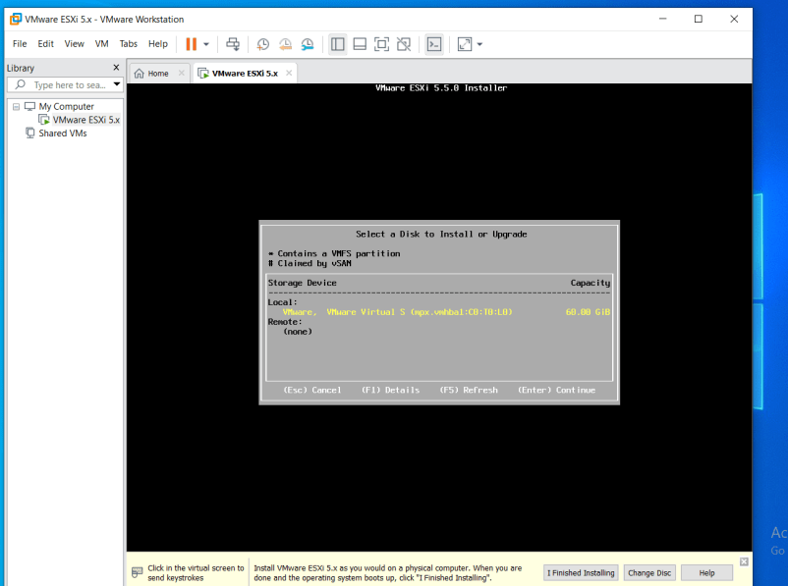

Press “Enter”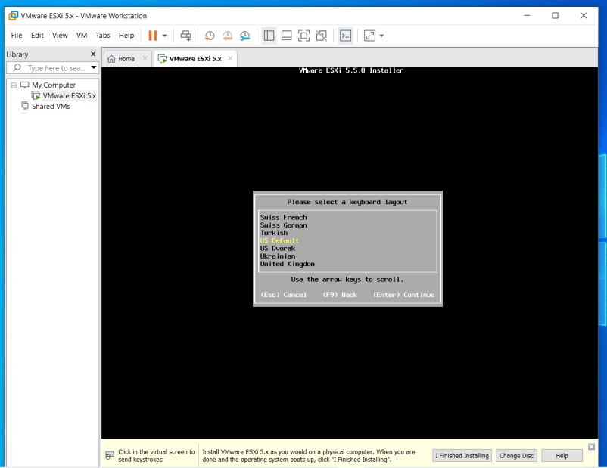

Press “Enter”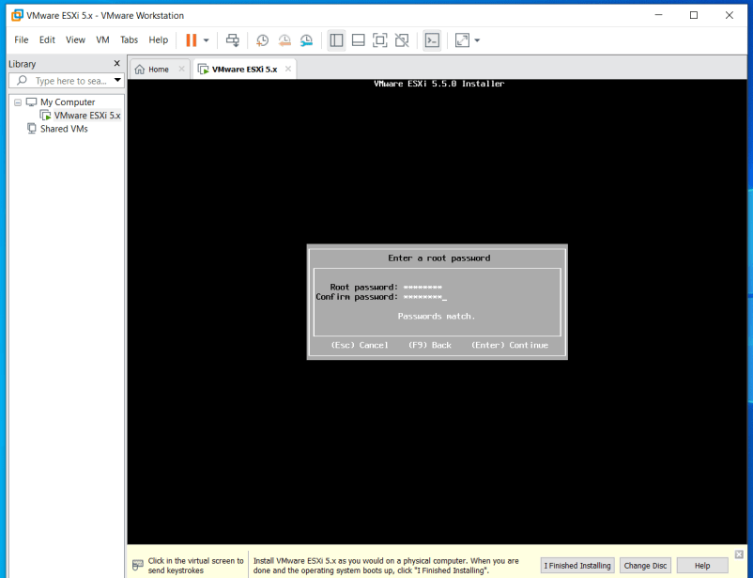

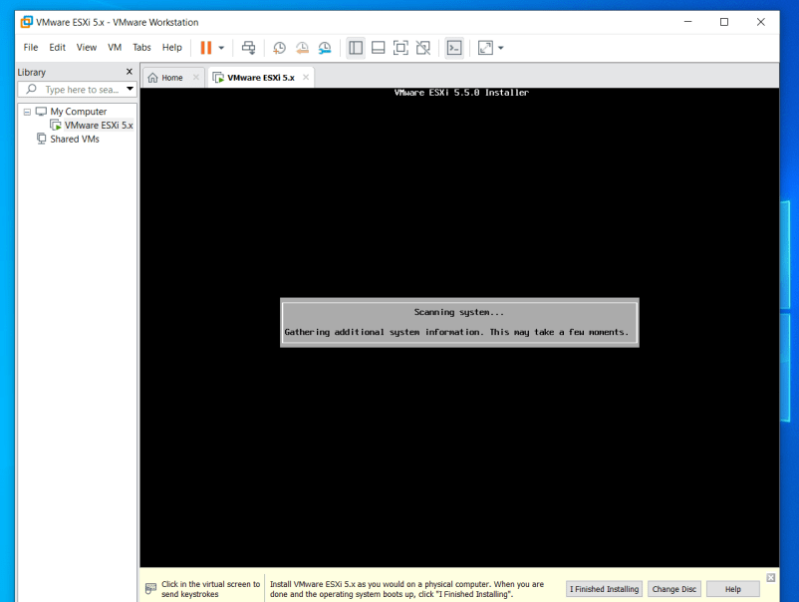

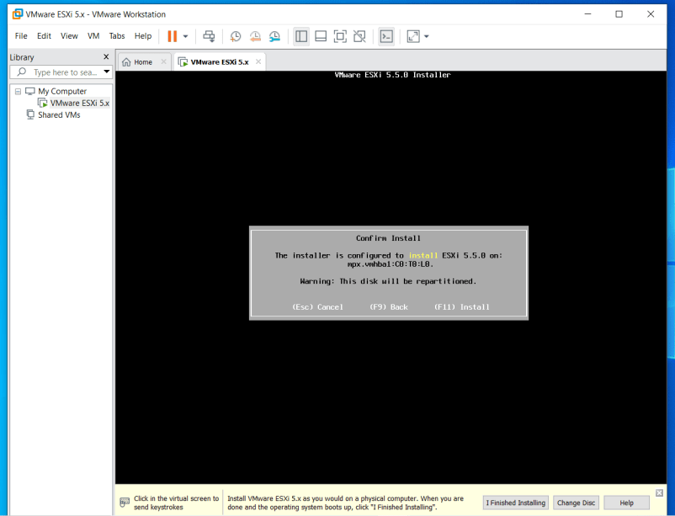

Click F11(Install)

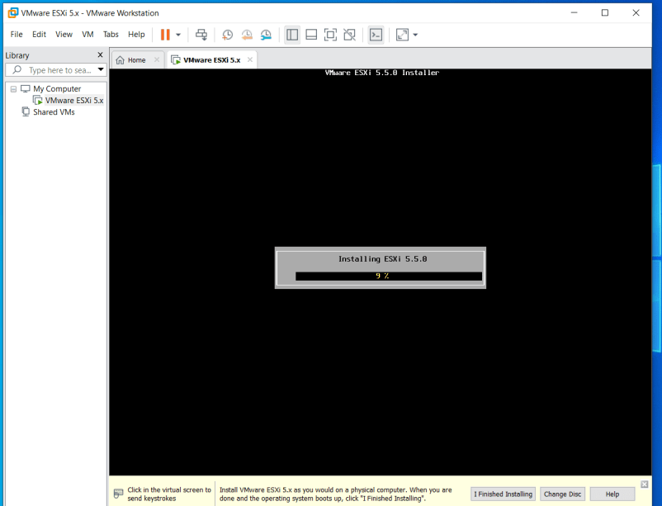

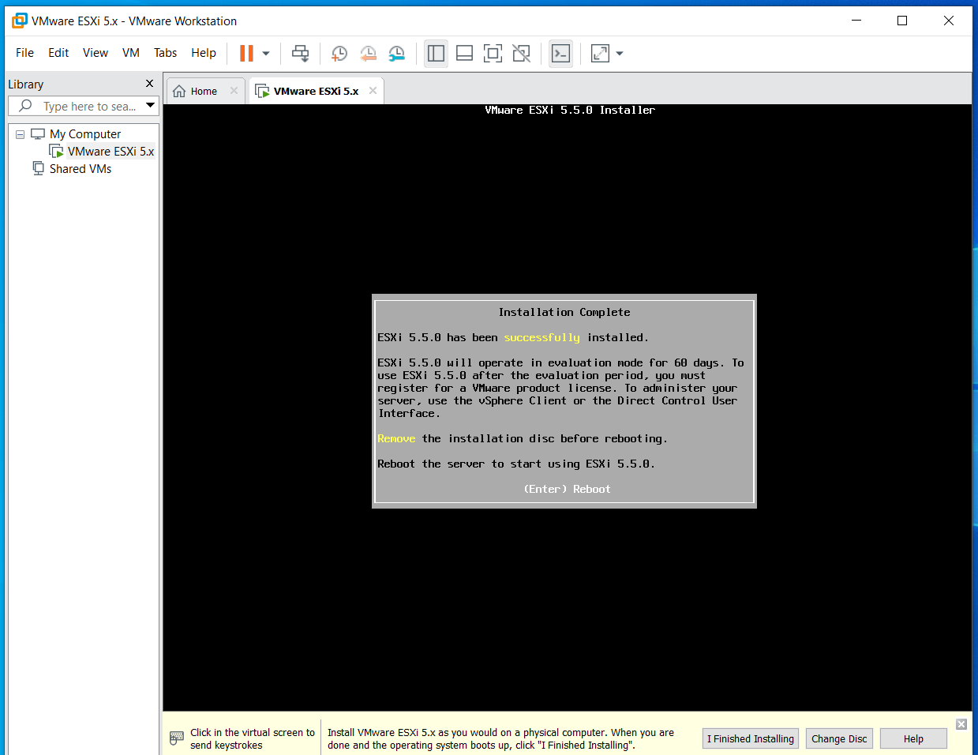

Press enter to reboot the system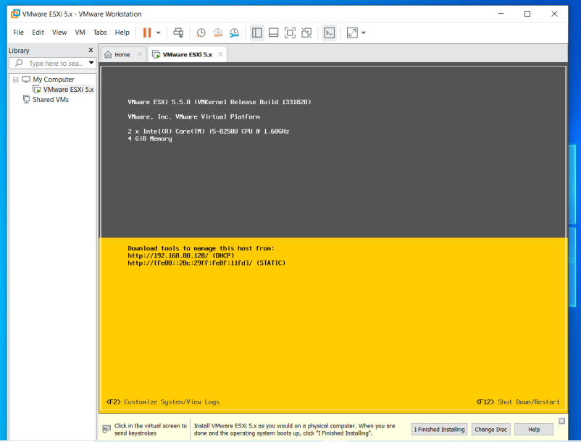

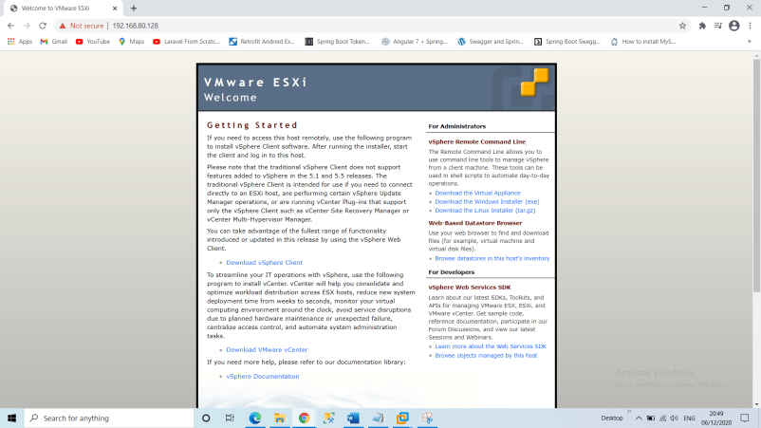

(since we already have vsphareclient so we are not going to download it,first install and open vsphareclient)

6.VMware vSphere Client

Enter IP address (Which was assigned dynamically) and Enter Username and Password

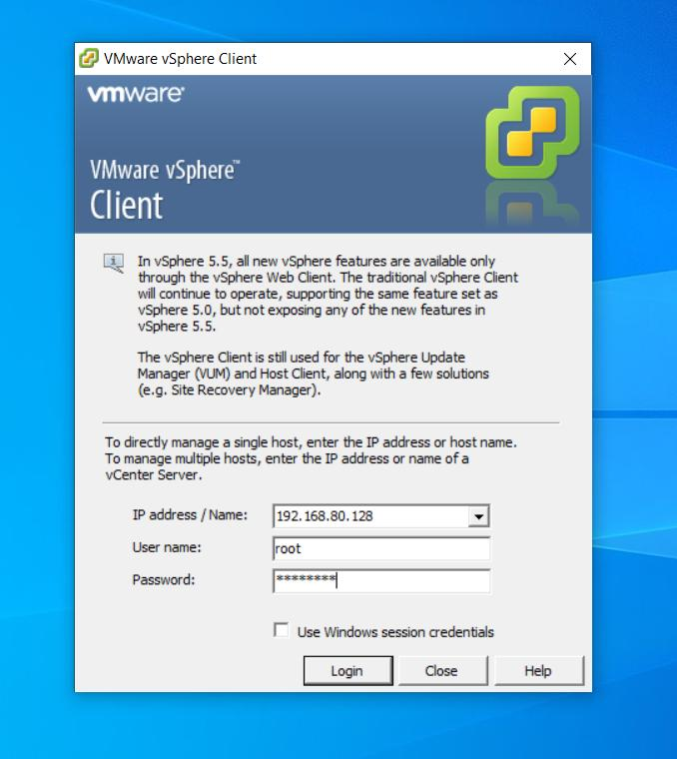

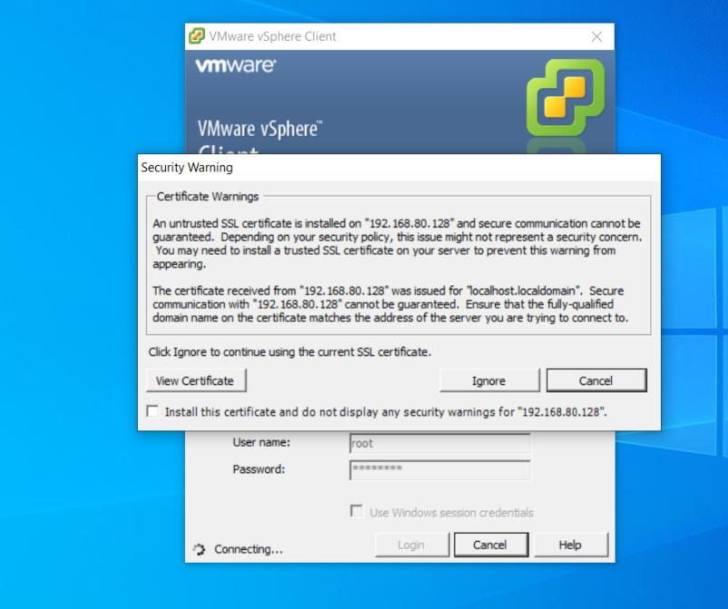

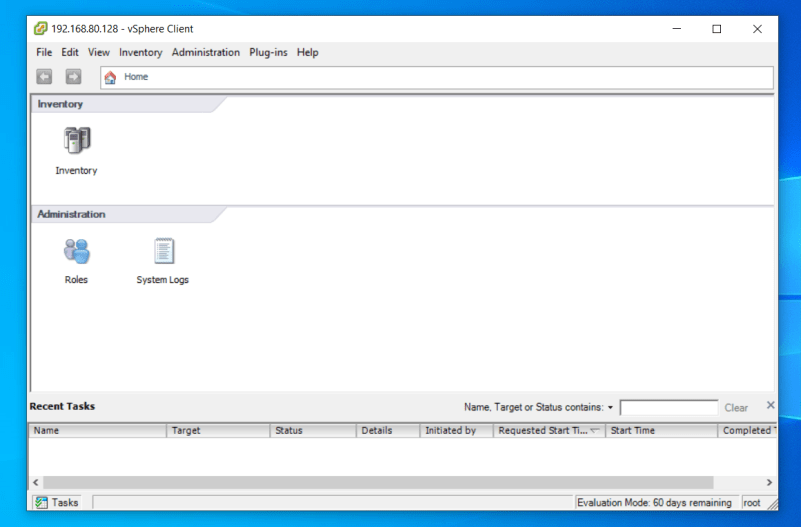

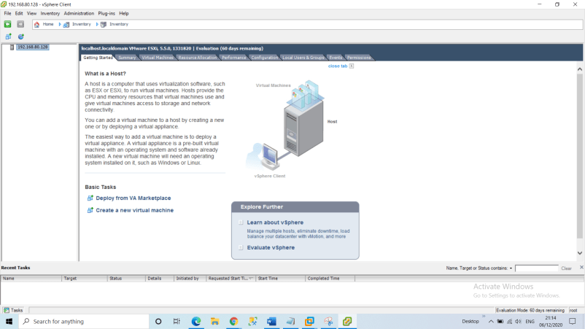

7.Select Summary tab. In Storage section, Select on datastore1 and Right-click on Browse Datastore to add iso image of Windows XP in Datastore.

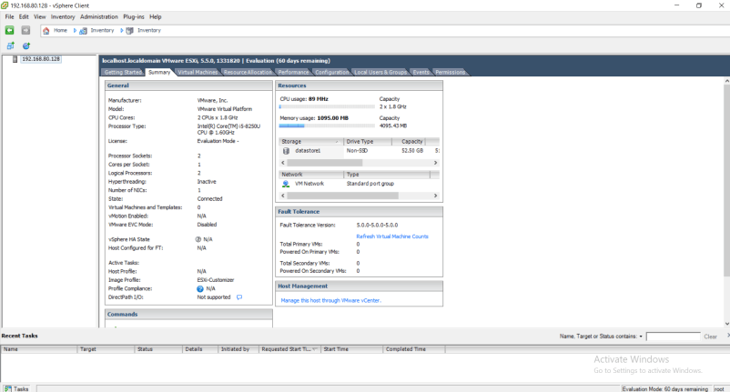

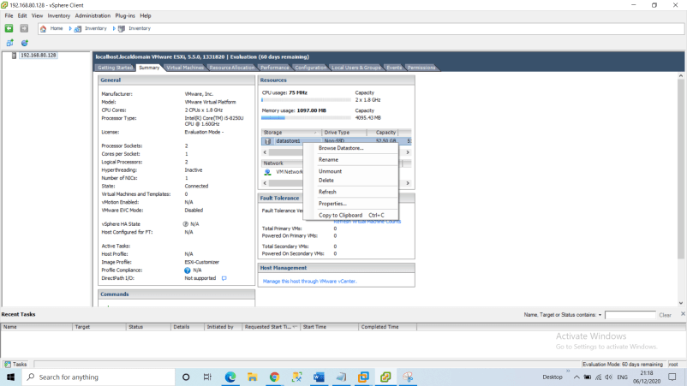

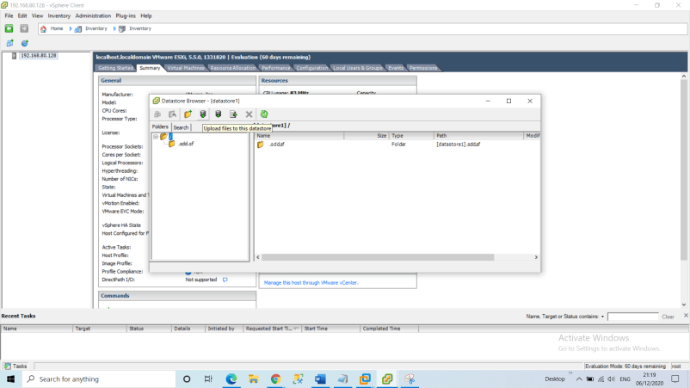

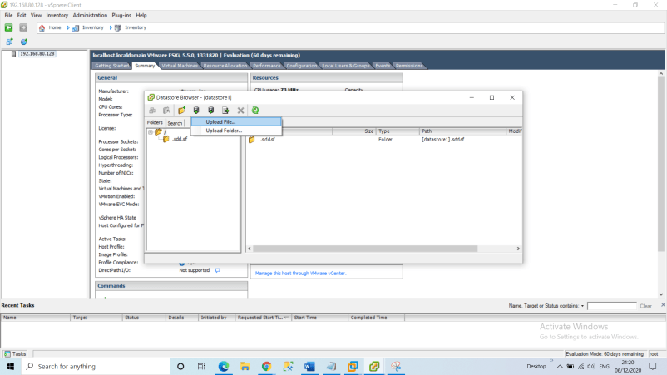

8.Click on Upload Icon and Select Upload File

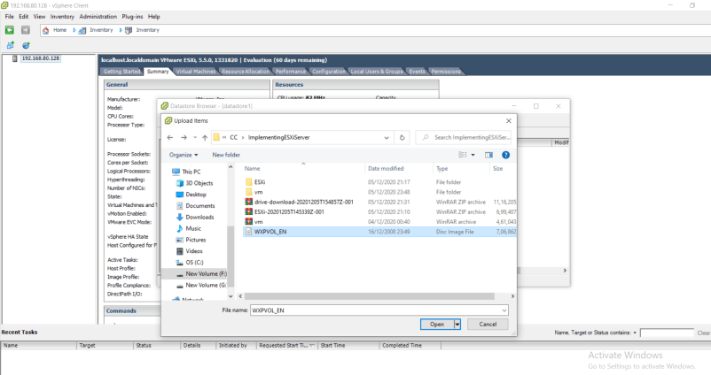

Click on Yes when warning “About Source and Target Location” is asked.

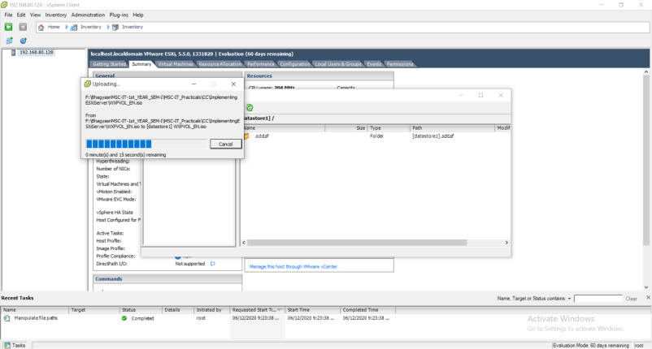

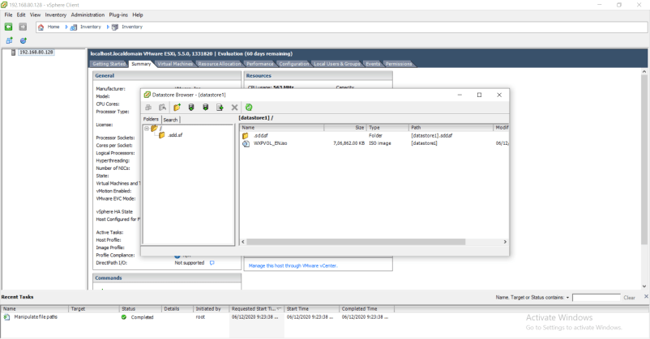

9.Click on File >> New >> Virtual Machine. Configuration : Select Custom configuration.

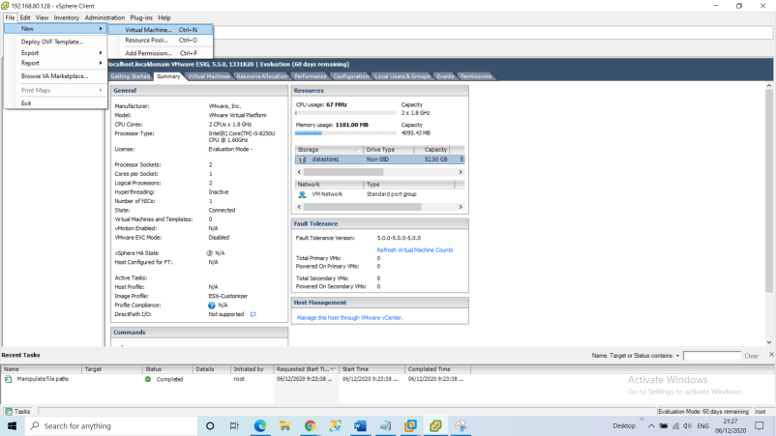

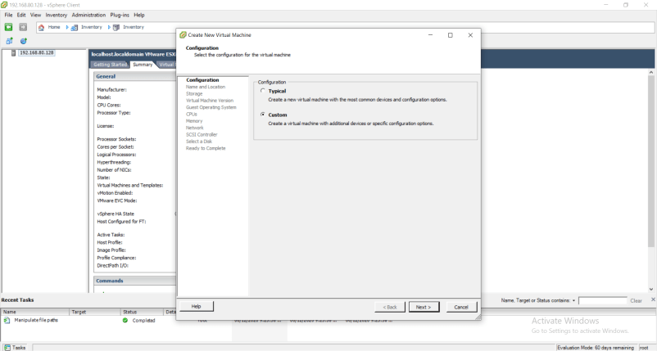

Click on Next

And for option “Name and Location” : Give name to a Virtual Machine(Windows XP)

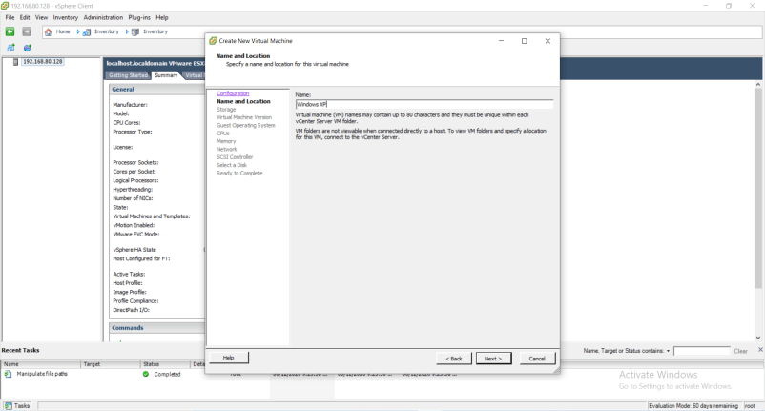

Click on Next

Storage:Select datastore1 and click Next

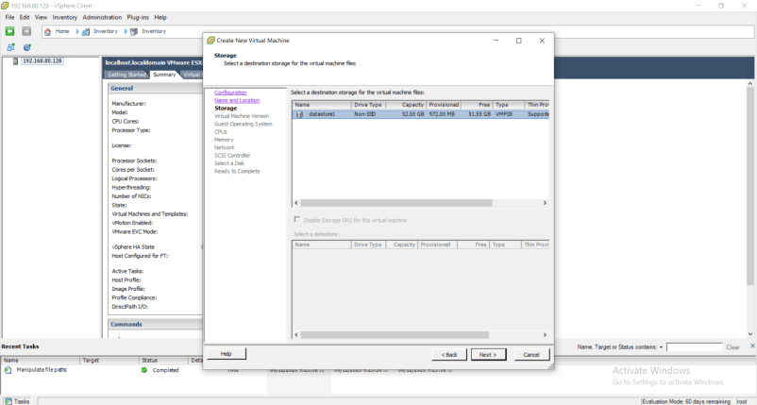

Virtual Machine version : Select Virtual Machine version 8 and click on Next

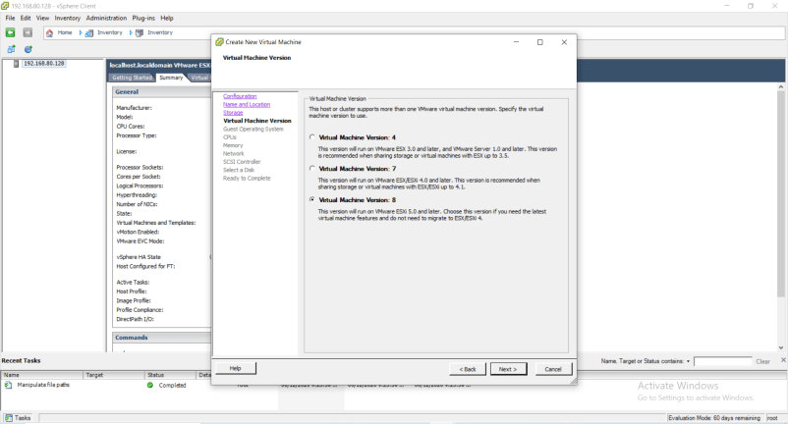

Guest Operating System: Windows Version: Microsoft windows XP Professional (32-bit) and Click on Next

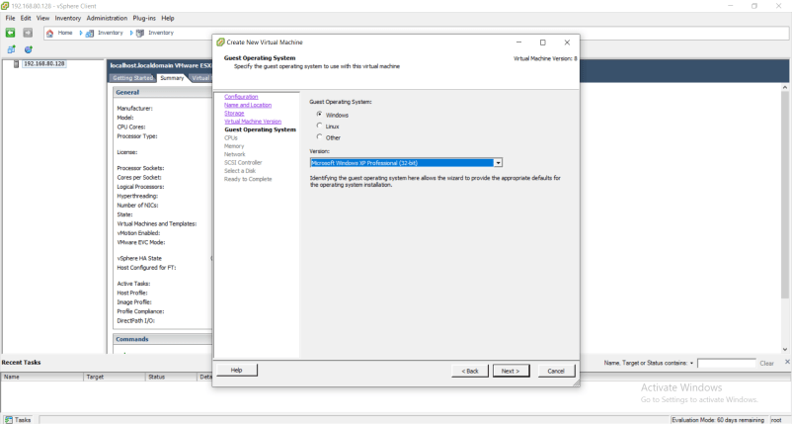

CPUs : Number of virtual sockets : 1 Number of cores per virtual socket: 1 and click Next

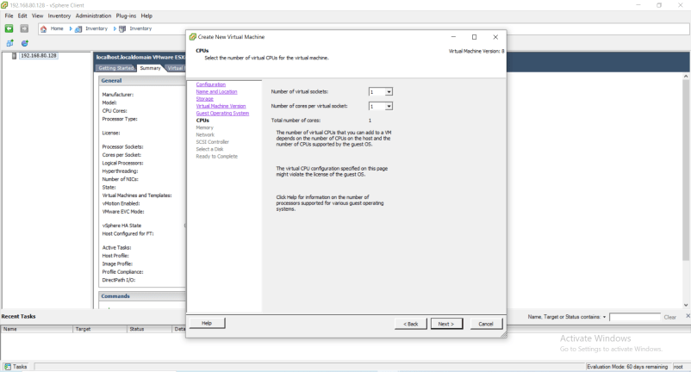

Memory: Memory Size : 1 GB and Click on Next

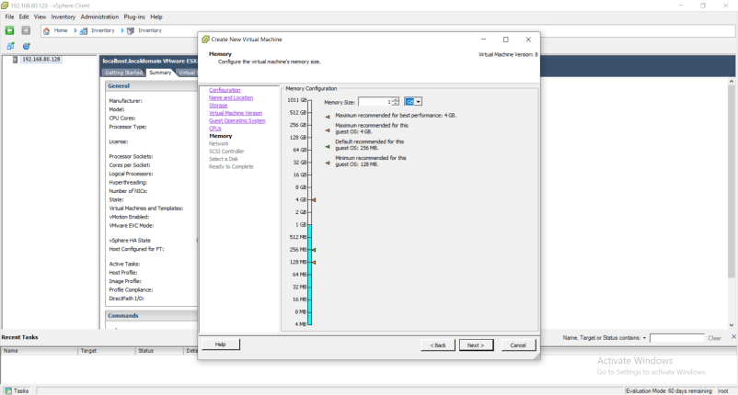

Network: Number of NICs : 1 and Click on Next

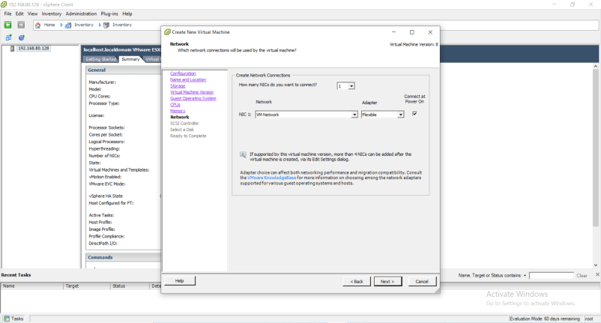

SCSI Controller : VMware Paravirtual and Click on Next

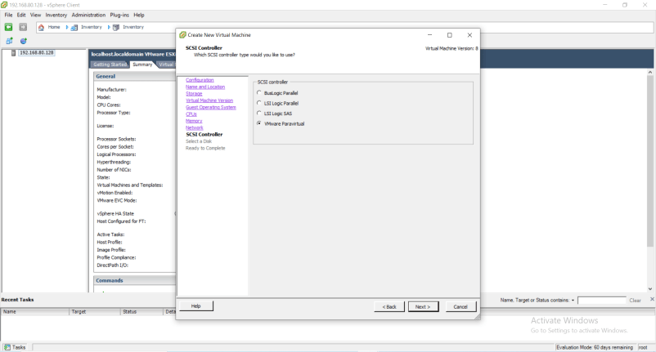

Select a Disk: create new virtual disk and Click on Next

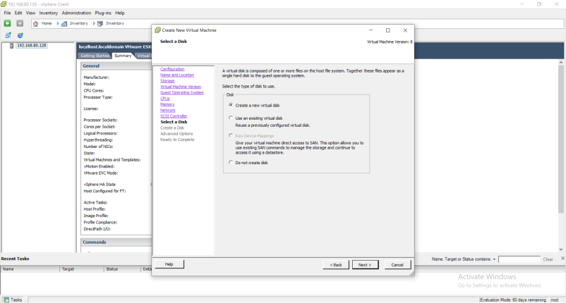

Select Disk Provisioning: Thin Provision and Click on Next

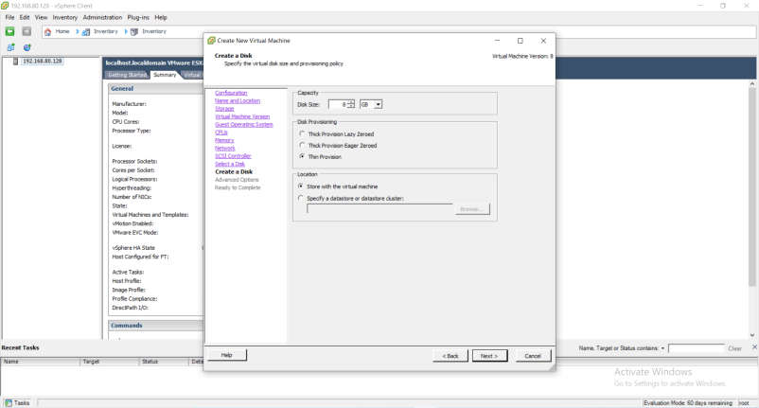

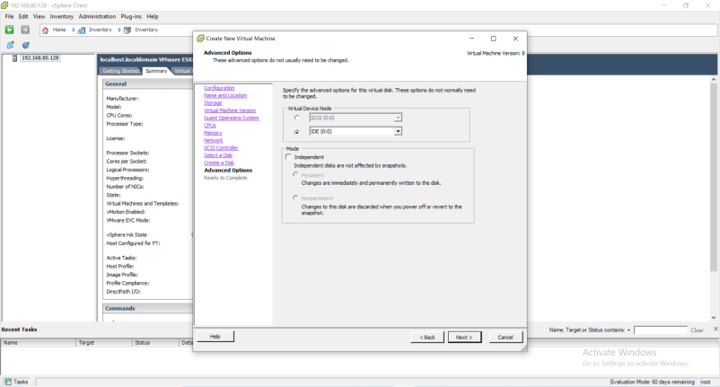

Click Next

Check the checkbox “Edit the virtual machine settings before completion” and click “Continue”

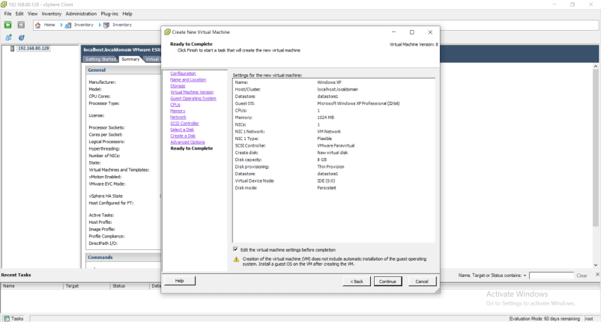

Click on radio button “Datastore ISO File” and click on Browse

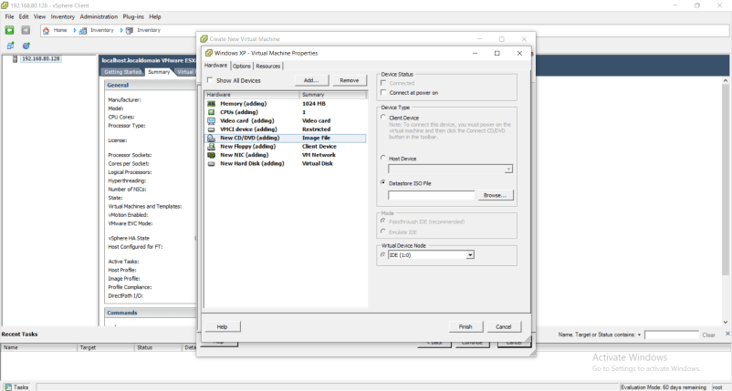

Select on “datastore1” and click on “Open”

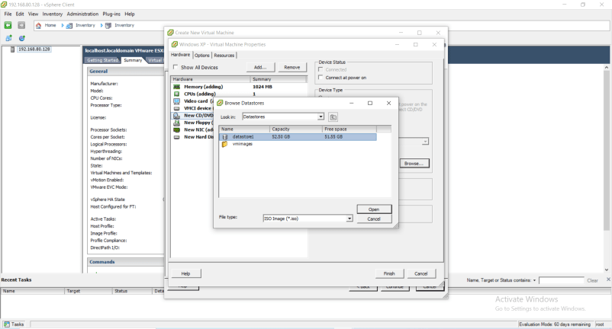

Select on “WXPVOL_EN.iso” and click OK

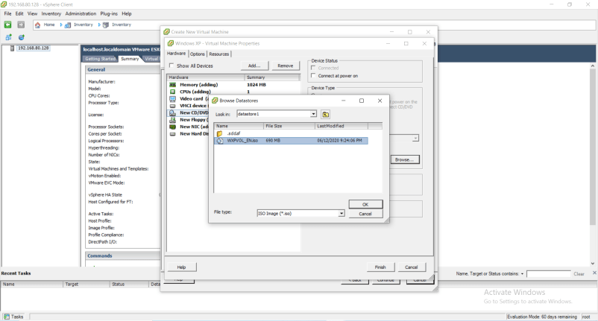

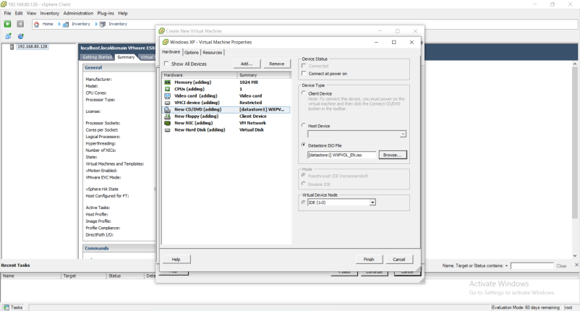

Click Finish

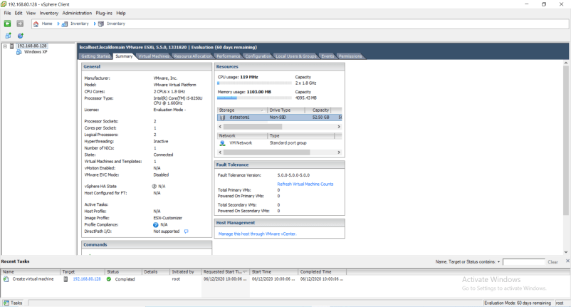

9.Right Click on Windows XP >> Power >> Power On

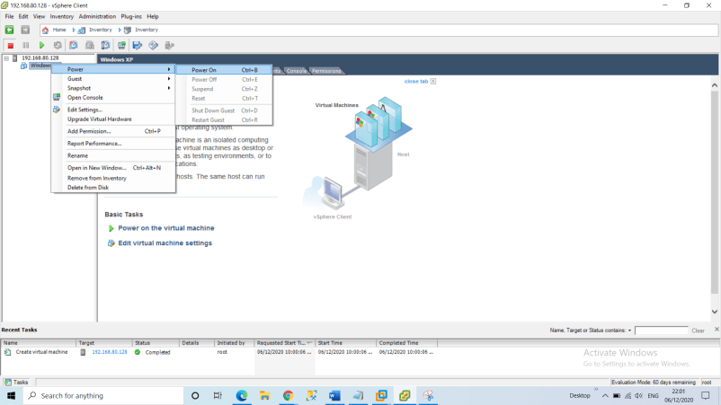

You will in the task section the status as “Completed”

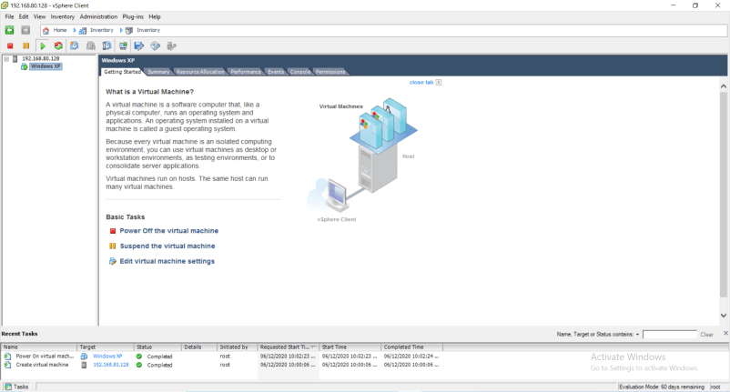

Sometimes, on console you may get as “Operating system not found” at that time.

1. First “Power off the machine”
2. Right click on the VM created i.e., Windows XP and click on edit Settings
3. Select CD/DVD Drive1: Check the checkbox “Connect at power on” and click on
4. And “Power on the machine” you will see the Welcome to Setup screen which means the OS is booted successfully.

